North Gloucestershire Orienteering Club

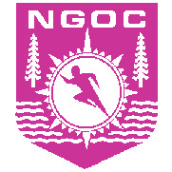

Code of Conduct for Parents / Carers

Effective from 30/11/2008

- Encourage your child to attend club coaching sessions and to learn new skills.

- Help your child to recognise good performance, not just results.

- Never force your child to take part in orienteering or to run a course for which they are not ready

- Never punish or belittle a child for losing or making mistakes.

- Support your child's involvement and help them enjoy their orienteering.

- Use correct and proper language at all times.

- ‘Fair Play’ in orienteering should be encouraged e.g. not complaining about the map, course planning, control placement; having respect for the countryside; not tampering with controls; not entering out of bounds areas etc.

